## Tutorial Number:

## Group Number:

## Scribe for the week:

Group members

| Student number | Responsible for question(s) | Participated as required (Y/N) |
| --- | --- | --- |
|  | 1,4 |  |
|  | 2 |  |
|  | 3 |  |
|  | 5 |  |
|  | 6 |  |
|  | 7 |  |
|  |  |  |

**Notes**

The purpose of asking for submitted solutions to the tutorials includes the following:

* To ensure that all students in the class remain engaged and work consistently on the course
* To ensure that there is some peer interaction in the class so that you learn from each other. Peers may have understood material with a different perspective to that of the course lecturer.
* There is a social purpose – many students have lost contact with classmates over the past year. Collaborating on the tutorials (within your groups only!) means that you have some contact with humans every week! Please look out for each other.

The scribe is responsible for finalising the allocation of questions to group members and for submitting the solution in time. For each question (in numerical order), you may paste scans of neat, hand written solutions but code must be pasted in a machine readable format.

Groups must agree and allocate enough time for the scribe to collate and submit the solutions. Recommended time frame is before EOB on Fridays. Group members who miss the internally agreed deadline may be marked as “not participating” if their solutions are not supplied in time to be included in the submission.

Group members are encouraged to collaborate within the group on their problems but may not consult outside their groups. The tutorials each contribute 1% of your final mark (the last one is a bonus) – The marks are there to ensure that you take it seriously but count too little to make cheating worthwhile.

You may ask questions in the Forum or class sessions. Forum questions should be posted before Friday 8h00 to expect a response by the due date of the tutorial and your submission should not depend on an answer to thi.

# Question 1

The state differential equation can simply be found using the mass of the water as a function of its volume and density:

The algebraic output equation can be derived using the physical dimensions of the cone:



therefore:

The volume of the water in the cone is related to its mass by:

Thus, since the useful algebraic output equation is:

# 

# 

## 

## 1a)

Doing a units analysis of allows us to very quickly get the correct units of k:

therefore k has the units of

## 

## 1b)

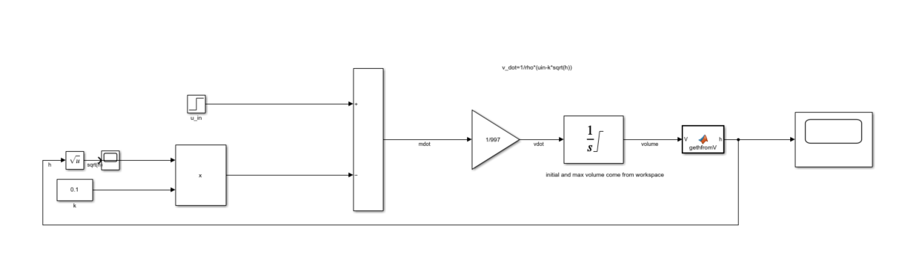

The model is shown above. With the initial height being 0.2m and the input being a step of 2kg/s after 20s, the following output is achieved:

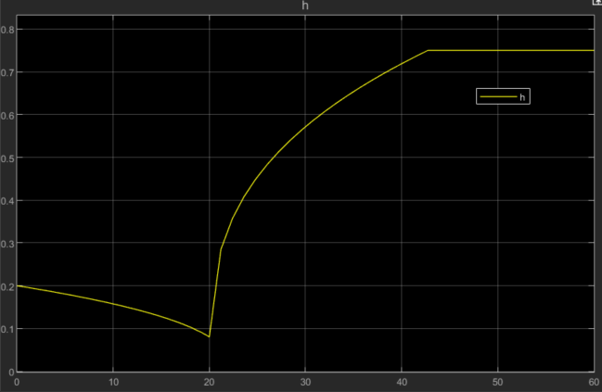

# 

# Question 2

# Question 3

# Question 4

It can be seen from the problem description that the mass of water as well as its volume are conserved. However, because the water mixes in the estuary and evaporates as a whole. It is more convenient to consider the volume of water being conserved. This gives the following situation and state differential equationDiagram, engineering drawing

The sea water can come into or out of the estuary. This equation accounts for this by allowing to be positive or negative. will be negative.

The algebraic output equation can be seen below:

This model was created in Simulink, screenshots below show the model as well as the output variables of the total volume and density of the water in the estuary

The Simulink model and matlab workspace can be found at: <https://github.com/DillBaggins/EEE3094-Tutorials/tree/main/Tutorial%202/Q4>

In my model I assumed the inflow from the sea to be periodic due to the tides. It can be seen that both the volume in the estuary and the density of the estuary oscillate with the frequency of the tides.

# Question 5

# Question 6

# Question 7